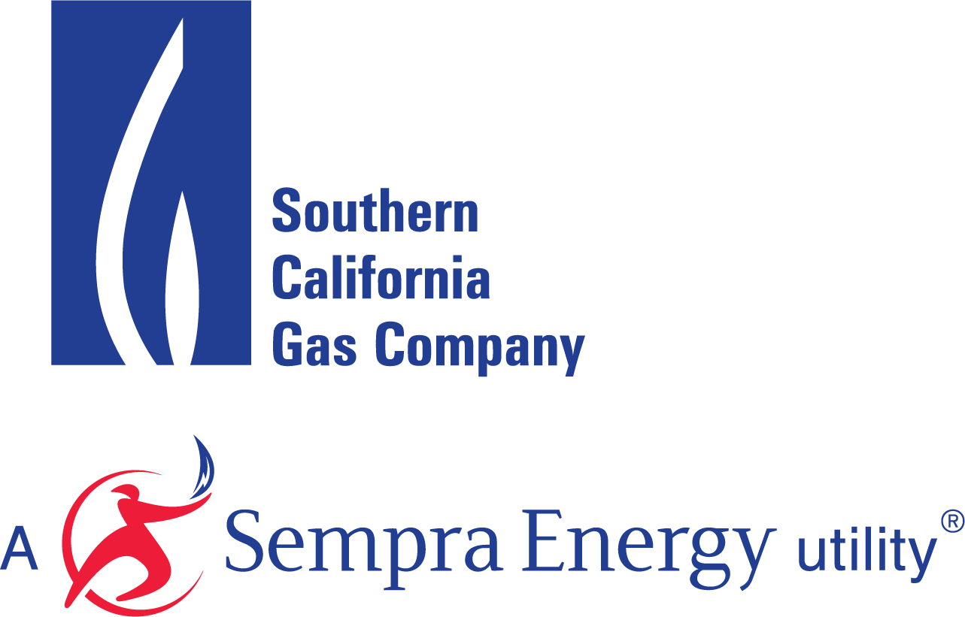

SELF-GENERATION INCENTIVE PROGRAM

DIRECTED BIOGAS SYSTEM OWNER

ATTESTATION

I, ______________________ (print name of System Owner), hereby attest that Directed Biogas will be procured complying with all applicable rules of the Self-Generation Incentive Program (SGIP) including but not limited to;
  - Contract will include term (minimum of 10 years), cost, amount of renewable fuel injected on a monthly basis for the length of the contract, address of renewable fuel facility, and facility address of Host Customer.
  - SGIP Program Administrators have the right to audit & verify Host Customer’s consumption of renewable fuel consumption upon request over the life of the contract.
  - The Host Customer will consume the contracted renewable fuel for the sole purpose of powering the SGIP systems.
  - The contract includes a forecast for at least 75% of the system’s anticipated fuel consumption.
  - The Project will be designed to be powered by at least 75% renewable fuel for at least 10 years.
  - The Renewable Fuel Supplier facility must produce fuel that meets the SGIP definition of renewable fuels.
  - The installation will use a revenue-grade, net generation output meter (NGOM) that can be remotely monitored by the utility for both electric output and gas consumption.
The undersigned understands that non-compliance to any SGIP requirements will be grounds for partial or complete incentive refund.
[SYSTEM OWNER]
Signature:
Name Printed:
Title:
Date:

