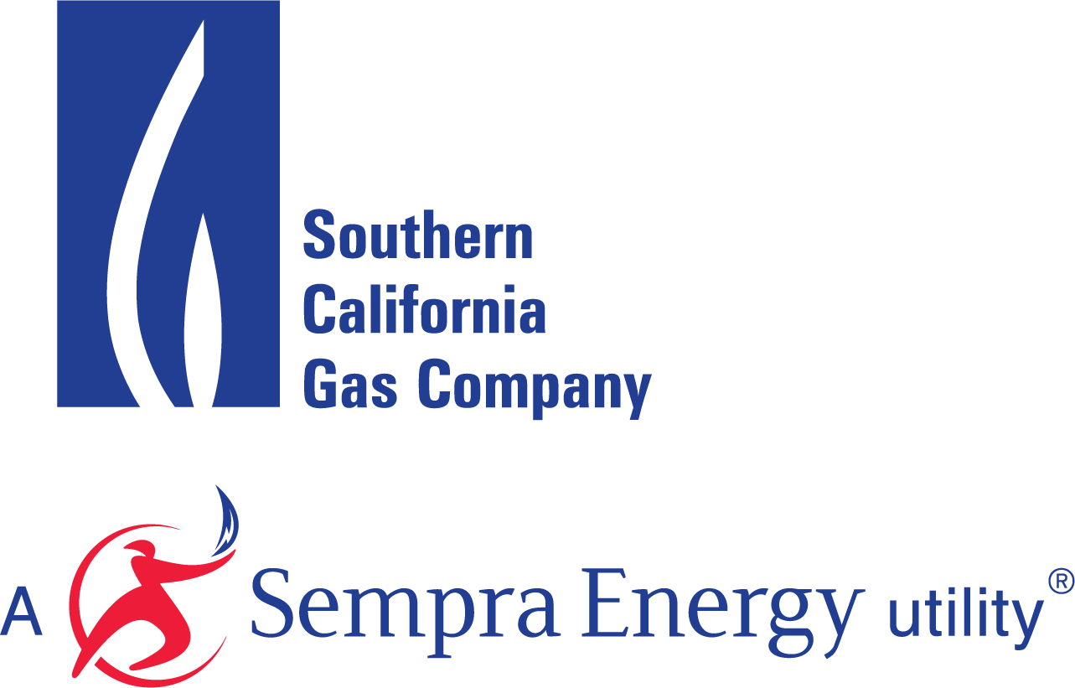

SELF-GENERATION INCENTIVE PROGRAM

WASTE GAS FUEL AFFIDAVIT

By signing this affidavit (“Affidavit”), Host Customer, ________________ and System Owner (if different than Host Customer), ________________, with respect to that self-generation project (“Project”) at ______________________, which is partially funded by ___________________ Self-Generation Incentive Program (“Program”) under Reservation Number , each certify and declare under penalty of perjury under the laws of the State of California that each of the statements in the paragraphs below are true and correct.

- “Term of Affidavit” begins the day Project becomes operational and connected to the electric utility’s grid and expires ten years later for a non-renewable fuel gas turbine, microturbine, fuel cell or IC engine project.
- The Project shall comply with the Program Waste Gas fuel requirements. The length of this commitment shall be the same as the equipment warranty requirement for the Project as defined in the Self Generation Incentive Program Handbook.
- Suitable onsite Waste Gas fuel for the Project is available for continuous operation of the self-generation unit for at least the Term of Affidavit described herein.
- Host Customer and System Owner shall use solely Waste Gas (100%) to operate the Project in any calendar year.

Each of the undersigned certifies under penalty of perjury that the foregoing is true and correct and that each is duly authorized to the Affidavit.

[HOST CUSTOMER] |  | [SYSTEM OWNER]  (if not Host Customer)
Signature: |  | Signature:
Name Printed: |  | Name Printed:
Title: |  | Title:
Date: |  | Date:
Place |  | Place

All communications under Affidavit shall be forwarded directly to:
Self-Generation Incentive Program
Program Administrator
Southern California Gas Company
555 West Fifth Street, GT-22H4
Los Angeles, CA 90013-1011
selfgeneration@socalgas.com

