QUESTION 1:

This question pertains to Chapter V (Estimated Conservation Impact of Providing Daily Gas Information to Customers).

Please provide a copy of all the studies quoted in Attachment SD-1 and Attachment SD-2.

RESPONSE 1:

Attached are copies of all studies referenced in Attachments SD-1 and SD-2 as found in Sarah J. Darby’s prepared testimony, Chapter V, Estimated Conservation Impact of Providing Daily Gas Information to Customers.

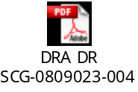

Response prepared by: Kerry Johnson

