Question 1: Please provide a spreadsheet that tracks and identifies each of the AMI operational benefits contained in Table III-10 (SCG-3, p. III-27) to its FERC Account or Subaccount on a year by year basis for the full AMI evaluation period for avoided expense benefits. Also, please provide the same information for avoided capital benefits tracking the AMI benefit to its SoCalGas Budget Number. Further, where any of the costs of those operational benefits differ from those costs authorized (or proposed and please differentiate the two) from those contained in SoCalGas’ 2008 general rate case, please reconcile, describe and quantify the difference between the operational benefit proposed in AMI and those contained in the 2008 GRC. Please ensure the information is reported on a year-by-year basis rather than on a present value basis.

SoCalGas Response 1:

The attached spreadsheet identifies each of the AMI operational benefits contained in Table III-10 of Mr. Serrano’s errata testimony with its FERC Account (O&M) or Budget Number (capital) (see column AQ). The operational benefits are shown on a year by year basis for years 2009 through 2034 (see columns M through AM).

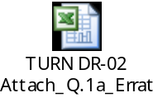

Also included below is a worksheet comparing the SoCalGas Test Year (TY) 2008 GRC authorized to the AMI benefits by FERC account or Budget Number when applicable.
Many of the activities with associated benefits included in the AMI business case are subsumed within various FERC Accounts and Budget Numbers or fall outside of the TY 2008 period, and thus not readily reconcilable at an itemized level to the amounts put forth in the TY 2008 GRC proceeding. All amounts are expressed in 2008$ direct costs (benefits). Full year 2016 or 2017 benefits include annual meter growth factor.

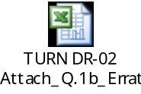

Response Prepared by: Kerry Johnson

Question 2: With regard to the meter reading benefits discussed on p. III-29 of SoCalGas’s AMI Testimony (SCG-3, p. 29), please reconcile the number of meter readers assumed to be avoided by AMI (i.e., 718 FTEs in 2008) with the number of estimated meter readers for 2008 (663 FTEs) contained in SCG’s 2008 Workpapers (A. 06-12-010, Workpapers Supporting SCG-7, Customer Services Operation, J. Patrick Petersilia, p. 81).

SoCalGas Response 2:

The following table reconciles the TY 2008 GRC meter reading FTEs with those discussed on p. III-29 in Mr. Serrano’s testimony, Exhibit SCG-3. The FTEs shown in the AMI column are actual positions in place as of September 2008. Due to the high turn-over rate in the meter reading department, this count will fluctuate from month to month. Please note that not included in the AMI FTE count are management (supervision and other staff) positions that were authorized in the TY 2008 GRC but were not added to the workforce. Those GRC FTEs not filled and not included in the table, 15 in total are included in the SoCalGas AMI as a benefit beginning in year 2009.

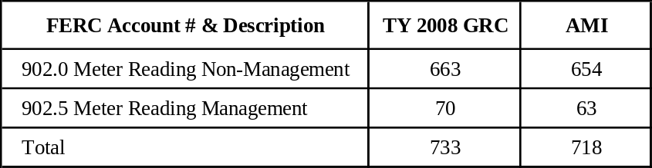

Response Prepared by: Kerry Johnson

Question 3: Has SoCalGas estimated any benefits from avoided Gas Telemetry activities? If not, please explain why not. If avoided Gas Telemetry is included as an AMI benefit please report where that benefit is calculated in SCG’s AMI workpapers.

SoCalGas Response 3:

SoCalGas has estimated the benefits from Gas Telemetry activities will be approximately $5.4 million in direct 2008 dollars as stated on p. III-36 of SoCalGas AMI Testimony (Exhibit No. SCG-3, p. 36). These costs are also included in Table III-10 within the “Customer Billing Services” O&M benefit $65.8 million within SoCalGas AMI Testimony (Exhibit SCG-3, p. 27).

Please refer to Mr. Serrano’s Workpapers for Chapter III, Section II.D. Billing Operations; 1.n. Ref 14 B-Non-Core Communications Expenses for the benefit calculation.

Response Prepared by: Kerry Johnson

Question 4: Please explain whether SoCalGas has included any benefits from avoiding the costs contained in FERC #184.4 (Tools and Uniforms). If SoCalGas has included those benefits please report where those benefits are contained in the AMI business case analysis. If they are not considered an operational benefit, please explain why.

SoCalGas Response 4:

SoCalGas erroneously excluded benefits for customer service field non-labor costs contained in FERC #184.4. The excluded benefit is calculated to be approximately $774,000 in year 2016 following full deployment of AMI and would continue on an annual basis during the project analysis horizon. The dollars presented in this response are shown in 2008 direct dollars.

Response Prepared by: Kerry Johnson

Question 5: Please explain whether SoCalGas assumes any benefits from reduced management of its meter reading force (FERC #902.5). If that operational benefit is contained in the AMI business case, please explain where it is contained in the benefits calculations, show how it was calculated and track the avoided costs back to SCG’s 2008 GRC (FERC #902.5) and reconcile and explain any differences between the AMI business case analysis, and the 2008 GRC. If SCG did not include avoided management or supervision of meter readers as an AMI operational benefit, please explain why.

SoCalGas Response 5:

Included in the SoCalGas AMI meter reading benefits are those associated with the reduction of the meter reading management workforce. The calculations for this benefit can be found in Mr. Serrano’s Workpapers for Chapter III; Section II.C. Meter Reading (MR); 1.a. Financial Template; reference numbers 12, 14-15, 18, 20-27, 41-44, 51-54 and 57-65; 1.b-c. Benefits Summary-Full (2011-2015) & (2016-2034); 1.i. Management; 1.m. GRC Mgmt Cost Benefits; and 1.n. Management 902.5 FERC – GRC.

The following table compares the authorized TY 2008 GRC forecast for 902.5 meter reading management and the comparable benefits in SoCalGas AMI for year 2017. The comparison is based on 2017 benefits as this is the first year following deployment when full benefits are recognized. The authorized GRC funding has been grown using the same growth rates used in the SoCalGas AMI filing in order to portray an equal comparison.

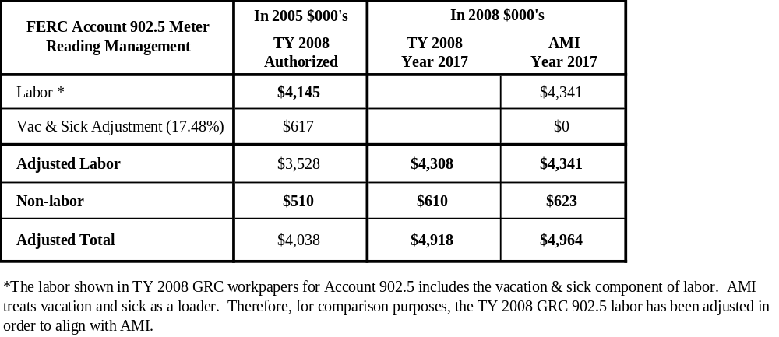

SoCalGas Response 5 - Continued:

See attached file for those line items from workpaper references discussed above that are specific to meter reading management benefits and the calculations used to derive the comparison results in the table.

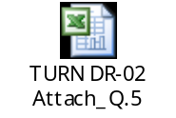

Response Prepared by: Kerry Johnson

Question 6: Please confirm that SoCalGas forecasts that its AMI deployment will result in the full elimination of “Change of Account” orders as explained in Chapter III of SoCalGas’ AMI application (p. III-34). If the SoCalGas is assuming full elimination of manual activities associated with “Change of Account” please explain why AMI will only eliminate 40 FTE when SCG’s 2008 GRC requested funding for 164 FTEs associated with “Change of Account” activities (A. 06-12-010, Workpapers supporting SCG-7, p. 30). Please provide all calculations, assumptions and other inputs used to support the response to this request.

SoCalGas Response 6:

Yes, SoCalGas AMI deployment will result in the full elimination of “Change of Account” orders as explained in Chapter III of SoCalGas’ AMI application (p. III-34). There are, however, differences in the definition of “Change of Account” orders and in the costs included within the “Change of Account” order category in the TY2008 GRC and the “Change of Account” order category in the SoCalGas AMI Application.

The costs and FTEs associated with the Change of Account orders in the TY2008 GRC are those required to complete all Non-Entered On Turn-On orders and all Read Only Close orders. These orders are sometimes completed on a single trip to a premise (“when they are “matched” and therefore counted as 2 different orders) and sometimes on different trips (one trip to close service for a customer and another trip to turn on service for a different customer).

In the SoCalGas AMI cost benefit analysis, Change of Account orders only represent the Non-Entered On Turn-On orders and Read Only Close orders that are “matched” and completed by Customer Services field personnel during a single trip to the premise. “Non-matched” Read Only close orders (performed on a different trip to the premise) will continue to be performed by SoCalGas field personnel after AMI implementation.

In the SoCalGas AMI cost benefit analysis, SoCalGas included the benefits associated with elimination of all Non-Entered On Turn-On orders (See Chapter III, pp 32-33), including those “matched” with Read Only Close orders as part of Change of Account orders. In addition, the “matching” Read Only Close orders are eliminated when quantifying the total benefits for Change of Account orders.

The TY2008 GRC

The TY2008 GRC filing lists a total of 198 FTEs associated with the completion of these orders. Detail regarding these FTEs is provided in the following table.

SoCalGas Response 6 - Continued:

164 FTEs | On-premise workforce required to complete the orders, including drive time
6 FTEs | Workforce required for “incomplete” orders
29 FTEs | Workforce required due to “other non-premise time” such as time between orders, meetings, truck stocking, meeting with supervisors, etc.
198 FTEs | Total

SoCalGas customer growth is projected to increase at the rates shown below.

Year | 2008 | 2009 | 2010 | 2011 | 2012 | 2013 | 2014 | 2015 | 2016
growth | base | 0.71% | 0.97% | 1.09% | 1.20% | 1.24% | 1.25% | 1.26% | 1.26%
FTEs | 198 | 200 | 201 | 203 | 204 | 206 | 207 | 209 | 210

Customer growth rates increase the forecast FTEs required to complete Change of Account orders from 198 FTEs in 2008 to 210 FTEs in 2016.

The SoCalGas AMI

Elimination of On Turn-On orders and “matched” Read Only Close orders (completed during the same trip to a premise as a Change of Account order that includes an On Turn-On order) occurs gradually over the five-year AMI deployment period, with full benefits for these activities being realized beginning in 2016. Benefits associated with eliminating On Turn-On orders and “matched” Read Only Close orders, beginning in 2016, are shown in red the table below.

 | Costs (millions) | FTEs
TY2008 GRC Change of Account orders |  | 210
- SoCalGas AMI On Turn-On orders | $198.1 | -113
Subtotal |  | 97
- SoCalGas AMI matching Read Only Close orders | $70.0 | -40
Subtotal |  | 57
Read Only Closes not eliminated by SoCalGas AMI |  | 57

It can be seen that in 2016, there are 57 FTEs of the 210 described in the TY2008 GRC that are not eliminated. These FTEs will be needed to complete Read Only Close orders that are not “matched” with On Turn-On orders.

Response Prepared by: Jose Pech, Jim Guillet, Mark L. Serrano

Question 7: Please explain why SoCalGas’ assumption that its AMI deployment will eliminate “Read & Verify” costs results in the elimination of a single FTE for a cost savings over the 2009-2034 period of $1.1 million when SoCalGas’ 2008 GRC workpapers indicate that approximately 25 FTEs work on approximately 145,000 “Read & Verify” orders per year at a cost of $1.56 mm per year (A. 06-12-010, Workpapers Supporting SCG-7, pp. 29-30).

SoCalGas Response 7:

Read & Verify orders are issued for a variety of reasons including, but not limited to: “Close if Vacant”, “Usage on Closed Meter”, Soft Close 180 Days”, “Soft Close Usage”, “Usage on Off Non-Pay Meter”, “Verify Address”, “Verify Meter Number”, “Verify Name”, “Verify Reason for Increased Usage”, “Verify Reason for Decreased Usage”, “Secure Appliance Data”, “Verify Heating Only”, “Read Meter”, etc.

In 2007, approximately 2% of all Read & Verify orders were issued exclusively to obtain a meter read. With SoCalGas AMI, these “meter read” only orders of the class of Read & Verify orders will not occur because AMI technology will provide a meter read. The other Ready & Verify orders requires customer services field personnel to complete other activities beyond the meter read (e.g., shut-off of the meter, verifying vacant premise, etc.). The Read & Verify orders that AMI will eliminate are in the “Read Meter” category listed above.

TY2008 GRC vs. SoCalGas AMI
 | Cost (millions)* | 2016 FTEs**
GRC Read & Verify orders | $1.567 | 25
R/V Reduction (%) | 2% | 2%
R/V Reduction in 2016 | $0.036 | 0.64
Post-Deployment R /Vs | $1.531 | 24.36

* Costs exclude Can’t Get In (CGI) costs, Miscellaneous Time costs and Vacation & Sick Time costs.
** Full benefits for this activity will be realized in 2016 following AMI deployment.

Response Prepared by: Jose Pech, Jim Guillet, Mark L. Serrano

Question 8: Please provide the percentage of “High Bill Inquiries” that SoCalGas assumes a) occur every year, and b) will be eliminated by AMI. Further, is it SoCalGas’ contention that AMI will only save one FTE over the deployment period versus its 2008 general rate case showing that it currently employs 8 FTE to investigate “High Bill Inquiries”. Finally, please reconcile SoCalGas’ assumptions concerning avoiding “High Bill Inquiries” benefits for AMI, with its showing in A. 06-12-010 and explain any and all differences between its AMI workpapers and its workpapers supporting SCG-7 in A. 06-12-009.

SoCalGas Response 8:

SoCalGas AMI will eliminate approximately one FTE over the deployment period. Approximately 7 FTEs will be employed to complete the fielded “High Bill Inquiries” that are not eliminated.

Similar to the Read & Verify orders identified in Question 7, HBI orders will not be completely eliminated by SoCalGas AMI. Historical data shows approximately 20% of the HBI orders requiring a field visit are due to errors made by meter readers. With SoCalGas AMI, only these types of HBI orders will be eliminated. Other HBI orders require the customer services field personnel to complete other activities and tasks (e.g., enter the premise to check appliances, etc.)

TY2008 GRC vs. SoCalGas AMI Forecast
 | Cost (millions)* | 2016 FTEs**
TY2008 GRC HBI orders | $0.525 | 8.34
AMI Reduction (%) | 20% | 20%
AMI Reduction | $0.036 | 1.7
Post-Deployment HBI orders | $0.489 | 6.64

* Costs exclude CGI costs, Miscellaneous Time costs and Vacation and Sick Time costs.
** Full benefits for this activity will be realized in 2016 following AMI deployment.

Response Prepared by: Jose Pech, Jim Guillet, Mark L. Serrano

Question 9: Please provide in electronic format SoCalGas’ responses to the 13th data request, and onward, of the Division of Ratepayer Advocates. Further, please provide all responses to any past or future DRA data responses deemed confidential. If there are any other intervenors in this proceeding asking data requests, also please provide all responses (confidential or public) to those parties’ data requests.

SoCalGas Response 9:

Attached please see the CD with DRA’s responses from DRA-DR13 going forward and please be apprised that the responses to DRA-DR2, 15, 19 and 33 are considered Confidential Material protected Pursuant to California Public Utilities Code Section 583, General Order 66-C And Applicable Non-Disclosure Agreements.

Response Prepared by: Billie Overturf

Question 10: Please explain whether or not SoCalGas’ AMI project will eliminate its Remote Access Meter Reading project (A. 06-12-010, Capital Workpapers Supporting SCG-7, p. CWP-1). If SoCalGas has not included elimination of this project’s capital and expense costs in its AMI business case analysis, please explain why? If it has included these benefits in AMI, please show where they are contained, and provide SoCalGas’ quantification of these AMI benefits, including all assumptions, calculations, and other factors supporting those benefits.

SoCalGas Response 10:

SoCalGas’ AMI project will impact the scope of its Remote Access Meter Reading (RAMR) project (A. 06-12-010, Capital Workpapers Supporting SCG-7, p. CWP-1).

As of mid-February 2009 approximately 179,500 gas AMR meter modules had been installed as part of the RAMR project. In 2008, when SoCalGas assessed the costs and benefits associated with implementing an AMI system, it found that company-wide deployment of AMI was cost effective and would produce long-term benefits. Based upon this finding, SoCalGas determined it should discontinue deployment of drive-by AMR technology as soon as practical.

Because SoCalGas had received funding for metering technology in its TY2008 GRC, SoCalGas determined that it would redirect TY2008 GRC funding from AMR to AMI. By so doing, SoCalGas could deploy a technology that would produce long-term benefits and avoid installing technology that might otherwise be removed from service before the end of its useful life.

SoCalGas did not include the cost or benefits of deploying AMI in the SDG&E/SoCalGas service territory in the SoCalGas AMI (approximately 106,000 gas meters). Per Prepared Direct Testimony, Edward Fong, Chapter II, p. II-15, lines 17-23.
“SoCalGas is planning to use the GRC RAMR funding for deploying AMI in the SDG&E overlap service territory.”

Response Prepared by: Mark L Serrano

