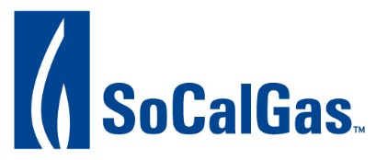
RETURN TO: Judy Delgadillo at JDelgadillo@socalgas.com

CREDIT APPLICATION

General Information

Legal Company Name

Doing Business As (D.B.A.)

Street Address City State Zip Code

Federal Tax ID #

Organized & existing under the laws of: (State) Year Incorporated/Established
Primary Contacts:
Credit Department Contact:
Name Title Phone FAX E-Mail
Gas Trader Contact:
Name Title Phone FAX E-Mail

Service Type: Estimated Volumes of Service Requested per month:
Contracted Marketer
Core Aggregator
Intrastate Transportation
Receipt Point Access Rights (Firm/
Interruptible/Off system)

Gas Storage
Trading (Gas Acquisition)
Hub Services
Other

Company References

Please list at least three references with which you are currently doing business: Company Name Contact Person Phone Number
1)
2)
3)

Please provide the following information with this application:

- Most recent three (3) fiscal years’, CPA audited, financial statements including notes to the financial statements.
- The most recent interim financial statements.
- A list of corporate affiliates, including addresses and relationship to your company/entity (Corporate Organization Chart).
- Most recent three (3) fiscal years’, CPA audited, financial statements of the ultimate parent company.

General Certification

The undersigned declares that the statements set forth herein are true and complete.

The undersigned on behalf of Applicant hereby authorizes Utility, to obtain verification from any source named herein as to the accuracy of the information provided and to obtain credit information regarding Applicant as part of its approval process.

The undersigned on behalf of Applicant hereby releases, discharges, exonerates and covenants not to sue any person, company or governmental organization providing information to Utility in connection with its approval process, any recipient of such information conducting a review of such information in connection with this application, including Utility or its representatives, and its officers, agents, employees and independent contractors, from any and all liability of every nature and kind arising from or in connection with the furnishing, receipt and review of such information.

Applicant understands and agrees that Utility means either: (i) Southern California Gas Company, if Applicant is applying for a service provided by that Utility; (ii) or, San Diego Gas & Electric Company, including its agent for credit approval purposes, Southern California Gas Company, if Applicant is applying for a service provided by SDG&E.

Official Signature:
(Must be signed by an officer of the Applicant)

Typed Name: Title: Dated:

