QUESTION DAO10-1:

Please provide the responses for the following questions electronically in an Excel Spreadsheet or Workbook:

Please identify the installation date for each “Station Start” and “Station Stop” segments (not hydrotest-segments) under every project listed in Appendix IX-1-A, on page WP-IX-1-Ai of the workpapers. For example, on page A2, there are 6 rows/segments of category 4 miles. Please identify the installation date of each segment. Please group the installation dates and individual segments in the same format presented in the workpapers.

RESPONSE DAO10-1:

SoCalGas/SDG&E has provided the requested installation date for the segments identified in Appendix IX-1-A, on page WP-IX-1-Ai of the workpapers in an excel file format similar to the workpapers. These excel files have been provided to DRA electronically on a CD that was express mailed on 11/14/11. Note lines for short segments not provided in a separate excel file are provided in the excel file “SCG Trans Short Crit Mile.xls”

Revisions:

Based upon data requests, discrepancies were identified in eight detailed workpapers for lines: 38-528, 235 West, 404, 406, 1004, 2000, 2001 East and 2001 West. The summary page of the individual project accurately reflected the category 4 criteria mileage, however the detailed project segment stationing and criteria mileage worksheets for the corresponding pipeline segments did not accurately reflect the criteria mileage for certain segments. The attached excel files contain the updated individual excel workpapers. The highlighted rows have been updated to accurately reflect the criteria category of the segment which also matches the category 4 criteria mileage of the individual project summary page. Note the highlighted rows may include additional station stop(s)/start(s) based upon the records review that identified additional workorders.
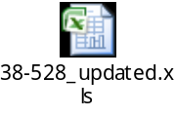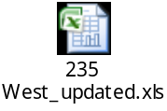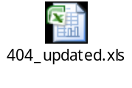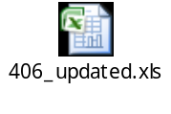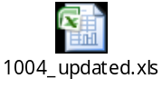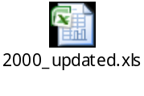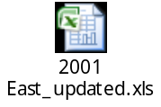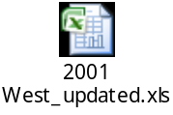

QUESTION DAO10-2:

Please identify the installation date for each of the “Station Start” and “Station Stop” segment (not hydrotest segments) of every project listed in Appendix IX-1-B, on page WP-IX-1-Bi of the workpapers. Please group the installation dates and individual segments in the same format presented in the workpapers.

RESPONSE DAO10-2:

SoCalGas/SDG&E has provided the requested installation date for the segments identified in Appendix IX-1-B, on page WP-IX-1-Bi of the workpapers in an excel file format similar to the workpapers. These excel files have been provided to DRA electronically on a CD that was express mailed on 11/14/11. Note lines for short segments not provided in a separate excel file are provided in the excel file “SCG Distribution Short Crit Mile.xls”

QUESTION DAO10-3:

Please identify the installation date for each “Station Start” and “Station Stop” segment of line 1600 as identified on page WP-IX-1-Ci of the Appendix IX-1-C of the workpapers for SDG&E Transmission. Please group the installation dates and individual segments in the same format presented in the workpapers.

RESPONSE DAO10-3:

SoCalGas/SDG&E has provided the requested installation date for the segments identified in WP-IX-1-Ci of the Appendix IX-1-C of the workpapers in an excel file format similar to the workpapers. These excel files have been provided to DRA electronically on a CD that was express mailed on 11/14/11.

QUESTION DAO10-4:

Please identify the installation date of each “Station Start” and “Station Stop”segment identified for all projects listed on page WP-IX-1-Di of Appendix IX-1-D, of the SDG&E Distribution workpapers. Please group the installation dates and individual segments in the same format presented in the workpapers.

RESPONSE DAO10-4:

SoCalGas/SDG&E has provided the requested installation date for the segments identified in WP-IX-1-Di of Appendix IX-1-D of the workpapers in an excel file format similar to the workpapers. These excel files have been provided to DRA electronically on a CD that was express mailed on 11/14/11.

