QUESTION TURN-TCAP-PSEP-02-01:

For the period from 2006-2011, inclusive, please provide the following information concerning the Sempra Utilities’ experience with in-line inspection tools. If the response is different for either SoCalGas or SDG&E during any portion of that period, please describe that difference:
- A listing and description of each type of in-line inspection tool used to inspect transmission and distribution pipes, including the method of inspection that the tool permits (i.e., MFI, TFI, etc).
- For each type of tool, the annual number of miles of pipeline inspected by an in-line inspection tool broken out by the type of tool used, and the diameter of the pipes that were inspected,
- The annual cost (per mile) for each type of in-line inspection.

RESPONSE TURN-TCAP-PSEP-02-01:

Below is a listing and description of each type of in-line inspection tool used to inspect transmission and distribution pipes, including the method of inspection that the tool permits.

Magnetic Flux Leakage (MFL): a type of inline inspection technique that induces a magnetic field in a pipe wall between two poles of a magnet. Sensors record changes in the magnetic flux (flow) which can be used to evaluate metal loss.
Transverse Field Magnetic Flux (TFI): TFI technology incorporates a magnetic flux technique to detect and characterize narrow axially-oriented anomalies by inducing a circumferential field path, rather than a longitudinal one. This method is sensitive to defects not normally detected by conventional magnetics, such as narrow axial external corrosion, cracks in long seam welds, gouges, axial notches in dents—as well as large individual cracks or large colonies of stress corrosion cracking (SCC).

Ultrasonic Compression Wave Tool: Conventional compression wave ultrasonic technology directs high frequency sound waves from probes located on the pig radially into the pipe wall and measures the delay in the return, or reflected, signal to identify metal loss (a process analogous to radar).
Deformation / Caliper tools: Caliper smart pigs are used to determine the internal diameter of the pipeline. The caliper inline inspection technique is designed to detect, locate and size geometric anomalies in the pipe wall.

At a minimum SoCalGas and SDG&E use both the High Resolution MFL and Caliper/Deformation tool, at least once, for each run. In addition to running the High Resolution MFL and Caliper/Deformation tools, SoCalGas has run an additional two tools on three pipelines:
- Ultrasonic Compression Wave Tool on L80 in 2003 approximately 0.6 miles long and on L2001 in 2007 approximately 6.2 miles
- Transverse Field Magnetic Flux Tool on L317 in 2011, which is approximately 1.1 miles.
The following is a breakdown of miles inspected by Diameter:
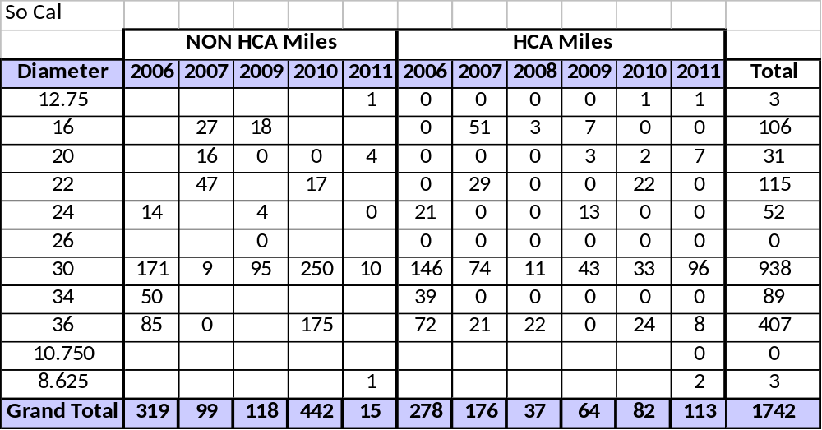
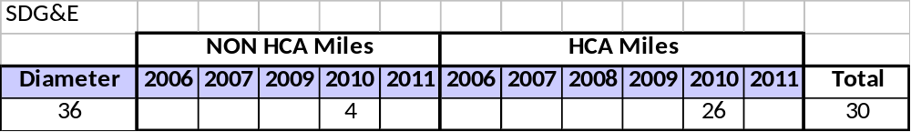
See also Response TURN DR-01-07(c-d), which is provided along with this response and which will be available on the SoCalGas website at the following link: http://socalgas.com/regulatory/R11-02-019.shtml

QUESTION TURN-TCAP-PSEP-02-02:

Please provide all of the foundational cost and operational information that support the Sempra Utility estimates (at Amended Testimony, p. 111) of the following:
- $200,000 per each run of an in-line inspection tool,
- 2 digs per run (at $50,000 per dig), and
- Excavation and repair costs of $75,000 per mile.

RESPONSE TURN-TCAP-PSEP-02-02:

See Response DRA-DAO-21-03(d), available on the SoCalGas website at the following link: http://www.socalgas.com/regulatory/R11-02-019.shtml

QUESTION TURN-TCAP-PSEP-02-03:

Please provide a description of each technology that SoCalGas intends to use for completing in-line-inspections for 2012-2020, including but not limited to
- The name of the technology,
- Each company that owns the rights to that technology, and
- The relationship that either or both of the Sempra Utilities (i.e., SoCalGas or SDG&E) have with any and all owners of the in-line inspection technologies. If the Sempra Utilities or any other subsidiary of Sempra Energy have any ownership arrangements or royalty or revenue sharing arrangements with the owners any of its proposed in-line inspection technologies, please explain the nature of those arrangements.

RESPONSE TURN-TCAP-PSEP-02-03:

The technology that SoCalGas intends to use for completing in-line-inspections for 2012-2020 will be based on specifications outlined in the Request for Proposals (RFP) for each individual inspection. Each vendor must adhere to these requirements for the inspection and the correlating inspection tool will be used. To date, the following vendors have been used, with the correlating tools used, at SoCalGas:
In-line Inspection Tool | Company That Owns Technology
High Resolution MFL | Baker Hughes PMG, Enduro Pipeline Services, NDT Systems & Services, GE PII, Rosen USA, TD Williamson, Weatherford US L.P
Transverse Field Magnetic Flux (TFI) | Baker Hughes PMG, NDT Systems & Services, GE PII, Rosen USA, Intratech ILI Services
Ultrasonic Compression Wave Tool | Baker Hughes PMG, NDT Systems & Services, GE PII, Rosen USA
Deformation /Caliper Tool | Baker Hughes PMG, Enduro Pipeline Services, NDT Systems & Services, GE PII, Rosen USA, TD Williamson, Weatherford US L.P

SoCalGas and SDG&E plan to use the TIGRE (Transmission-Line Inspection of Gas Mains via Robotic Explorers) and the Explorer in-line robotic inspection systems during the PSEP implementation period. The key feature of TIGRE and Explorer is that they can inspect unpiggable pipeline segments, without having to shut down the pipeline. SoCalGas has co-funded and participated in the TIGRE and Explorer projects at NYSEARCH, a member-supported research and development division of the Northeast Gas Association (NGA). NGA licensed its robotics technology to Invodane Engineering, who is developing a commercial system. Invodane will pay royalties for using TIGRE and Explorer to the NYSEARCH Robotics LLC. NYSEARCH Robotics LLC has a revenue sharing agreement with eligible members, and SoCalGas’ share, based on our co-funding interest, is 12.3%. To date, there has been no distribution of revenues to members from NGA/NYSEARCH.

QUESTION TURN-TCAP-PSEP-02-04:

Please list the types of pipes and diameters of pipelines that may accommodate in-line inspections as described in the amended workpapers (dated 12/2/2011, pp. 38-43).

RESPONSE TURN-TCAP-PSEP-02-04:

Each pipeline listed on pages WP-IX-1-39 and WP-IX-1-43 of the workpapers supporting Chapter IX of the Testimony has a corresponding detailed workpaper in either Appendix IX-1-A or IX-1-C that contains further information, including the pipeline diameter.

QUESTION TURN-TCAP-PSEP-02-05:

Please provide any and all reports and studies (whether in draft or final form) completed by SoCalGas (or its technology partners (i.e., Northeast Gas Association, American Gas Association, Department of Transportation, Operation Technology Development Corporation, InvoDane Engineering, Ltd., etc.) discussing SoCalGas’ test of the Intermediate TIGRE technology that occurred in November of 2010, and any test of that technology that has occurred since then. Please also state the dates of each test of this technology.

RESPONSE TURN-TCAP-PSEP-02-05:

Please see the attached files for presentations updating the status of the TIGRE system since November, 2010. Since SoCalGas’ field demo, upgrades to the intermediate TIGRE system have been under development. A prototype of the new system was tested at a NYSEARCH pipe farm in New York on 12/12/2011. The most recent field trial occurred the week of May 14, 2012. Reports for this latest trial are not yet available. Additional field tests are planned in June and July, 2012, but are subject to change.

Please note that some of these presentation slides have been copied in such a way as to preserve proprietary and confidential information.

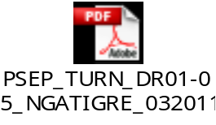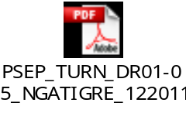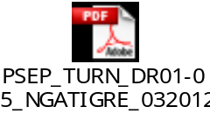

QUESTION TURN-TCAP-PSEP-02-06:

Please provide all information, records, and studies possessed by the Sempra Utilities concerning the experience of other gas utilities using in-line pipeline inspection technologies and techniques. If the information, records and studies are so voluminous that the Sempra Utilities contend it would be unduly burdensome to provide all of them, please provide the ten that, in the view of the Sempra Utilities, reflect a representative sample of that information, records and studies.

RESPONSE TURN-TCAP-PSEP-02-06:

Beyond confidential industry conference proceedings, SoCalGas and SDG&E do not maintain information regarding the experience of other gas utilities with in-line inspection.

For a detailed primer on the capabilities of in-line inspection tools, see the background information available in the archived copies of the June 24, 2011 Educational Symposium on In-Line Inspection of Gas Pipelines located on the CPUC website at: http://www.cpuc.ca.gov/NR/rdonlyres/0DEA7BA4-5421-4287-BD32-A22863A2BFE9/0/INLINEINSPECTIONSYMPOSIUMCONCATENATEDFINAL.pdf. Additionally, a pertinent document for review is the Interstate Natural Gas Association of America/ American Gas Association Report to NTSB on Development of Advanced In-Line Inspection Platforms for Use in Gas Transmission Pipelines. This report was provided to the NTSB on March 26, 2012, and is available for download at the following link: http://www.ingaa.org/Filings/18021.aspx.

QUESTION TURN-TCAP-PSEP-02-07:

The following request refers to SoCalGas and SDG&E’s Status Report to the National Transportation Safety Board (dated June 24, 2011). At page 5 of that report, the report discusses four projects for which SoCalGas used an in-line inspection tool (TFI) to evaluate for specific pipelines, and indicates that the utility was awaiting a final vendor report on each of these projects. Please provide a copy of each of the four final vendor reports for the projects discussed in that report:
- 12 inch Line #317,
- 30 inch Line #2001 West (Moreno to Santa Ana),
- 30 Inch Line #2001 West (Santa Ana to La Puente),
- 30 Inch Line 2003 West.

RESPONSE TURN-TCAP-PSEP-02-07:

The June 24, 2011 document referenced above is not a report to the National Transportation Safety Board, but rather, a status update letter submitted by SoCalGas/SDG&E to the CPUC on the subject of: Update to Report of SoCalGas and SDG&E on Actions Taken in Response to the National Transportation Safety Board Recommendations. Of the four pipeline segments identified for TFI in the letter, only one pipeline at that time (Line 317) had been inspected using a TFI tool, and the remainder were planned for TFI runs later in 2011.
At this time, the status of our inspections with regard to TFI has not changed. Only Line 317 has been inspected with TFI technology, and restricted tool availability and logistics have prevented inspection of the remaining pipelines.
The final vendor report for Line 317 is confidential, but will be provided to TURN upon execution of a non-disclosure agreement with SoCalGas.

QUESTION TURN-TCAP-PSEP-02-08:

For each year from 1997 through 2011, inclusive, for each utility please provide the following information on a recorded basis:
- The number of miles (or feet) of transmission (and distribution if applicable) pipeline that was retrofitted to accommodate inspections by “pigs” broken out by size of pipe,
- The annual cost of retrofitting those pipelines to accommodate in-line inspections, and
- A brief narrative describing the process of retrofitting pipelines to accommodate “pig” inspections, including any changes to the process that occurred during this period.

RESPONSE TURN-TCAP-PSEP-02-08:

Responsive data is only available dating back to the beginning of the TIMP program in 2003. All pipelines have undergone some amount of retrofitting to be able to accommodate in-line inspection tools. The mileage of these pipelines is provided in Response TURN DR-01-07(c) which is provided along with this response and will be available on the SoCalGas website at the following link: http://socalgas.com/regulatory/R11-02-019.shtml
For the annual cost of retrofitting those pipelines, see Response TURN DR-01-07(d) which is provided along with this response and which will be available on the SoCalGas website at the following link: http://socalgas.com/regulatory/R11-02-019.shtml.
Retrofitting pipelines to accommodate in-line inspections involves adding facilities (launcher and receiver) to the pipeline to enable insertion and removal of the inspection tools and elimination of any feature that would inhibit the passage of a tool at any point between the launch and receive sites. Such features include plug valves, elbows with too tight a bend radius, back-to-back bends within a certain threshold distance of each other, unbarred tees, diameter changes, and any intrusive monitoring or liquids removal.

QUESTION TURN-TCAP-PSEP-02-09:

For each year from 1997 through 2011, inclusive, for each utility please provide the following information on a recorded basis:
- The number of in-line [pig] inspections broken out by size of pipe,
- The number of miles associated with these in-line inspections, and
- The costs associated with these in-line inspections, broken into labor and non-labor.

RESPONSE TURN-TCAP-PSEP-02-09:

Responsive data is only available dating back to the beginning of the TIMP program:
SoCalGas
Date | Pipeline | Miles | Size
2003 | 2001 WEST | 74.9 | 30
2003 | 160 | 0.8 | 22
2003 | 1005 | 23.8 | 22
2003 | 80 | 0.6 | 12.75
2004 | 1175 | 2.0 | 30
2004 | 1005 | 0.4 | 22
2004 | 2000 | 75.5 | 30
2004 | 2003 | 11.8 | 30
2004 | 2002 | 3.4 | 30
2004 | 2003 | 15.3 | 30
2004 | 2002 | 3.5 | 30
2004 | 2001 WEST | 7.2 | 30
2004 | 1170 | 5.9 | 30
2004 | 3007 | 4.4 | 30
2004 | 2001 WEST | 51.6 | 30
2005 | 2000 | 26.8 | 30
2005 | 235 WEST | 46.8 | 30
2005 | 1167 | 2.4 | 30
2005 | 335 | 65.0 | 30
2005 | 1027 | 34.4 | 16
2005 | 235 WEST | 64.7 | 30
2005 | 767 | 5.4 | 30
2005 | 1004 | 9.7 | 16
2005 | 4000 | 7.0 | 36
2006 | 1013 | 4.7 | 30
2006 | 1015 | 0.6 | 30
2006 | 2000 | 31.2 | 30
2006 | 1180 | 3.8 | 30
2006 | 4000 | 35.6 | 36
2006 | 4002 | 33.2 | 36
2006 | 225 | 12.9 | 34
2006 | 235.01 | 0.2 | 24
2006 | 235.02 | 0.3 | 24
2006 | 225 | 11.3 | 34
2006 | 324 | 35.4 | 34
2006 | 4000 | 76.7 | 36
2006 | 3000 WEST | 44.3 | 30
2006 | 1028 | 34.5 | 24
2006 | 3003 | 29.1 | 34
2006 | 407 | 12.5 | 30
2006 | 2001 EAST | 6.5 | 30
2006 | 2000 | 6.2 | 30
2006 | 1014 | 23.5 | 30
2006 | 2000 | 73.0 | 30
2006 | 2006 | 5.5 | 30
2006 | 4000 | 0.0 | 36
2006 | 1192 | 11.3 | 36
2006 | 1030 | 31.8 | 30
2006 | 2001 EAST | 37.2 | 30
2006 | 2001 WEST | 5.7 | 30
2006 | 1181 | 5.2 | 30
2006 | 1018 | 24.8 | 30
2007 | 115 | 17.9 | 30
2007 | 8109 | 15.6 | 20
2007 | 1010 | 31.7 | 16
2007 | 1205 | 7.7 | 36
2007 | 35-20 | 21.0 | 16
2007 | 1024 | 1.6 | 30
2007 | 1176 | 3.8 | 30
2007 | 404 | 12.6 | 30
2007 | 800 | 26.0 | 22
2007 | 1016 | 13.4 | 36
2007 | 1004 | 10.1 | 16
2007 | 404 | 24.1 | 30
2007 | 765 | 6.2 | 30
2007 | 765 | 17.2 | 30
2007 | 127 | 1.6 | 16
2007 | 1004 | 21.1 | 16
2007 | 406 | 50.1 | 22
2008 | 765 | 6.2 | 30
2008 | 1019 | 14.5 | 36
2008 | 1027 | 34.4 | 16
2008 | 1202 | 7.6 | 36
2008 | 1200 | 3.3 | 16
2008 | 3001 | 5.2 | 30
2009 | 1020 | 6.0 | 30
2009 | 247 | 24.4 | 16
2009 | 7039 | 17.0 | 24
2009 | 235 WEST | 118.4 | 30
2009 | 2000 | 10.1 | 30
2009 | 1173 | 2.9 | 20
2009 | 1172 | 3.4 | 30
2010 | 3002 | 0.4 | 30
2010 | 5000(2) | 69.9 | 36
2010 | 5000(4) | 7.2 | 36
2010 | 5000(3) | 31.4 | 36
2010 | 2051 | 45.0 | 36
2010 | 2001 WEST | 75.7 | 30
2010 | 160 | 0.8 | 22
2010 | 1005 | 38.3 | 22
2010 | 6905 | 31.7 | 36
2010 | 80 | 0.6 | 12.75
2010 | 4002 | 13.6 | 36
2010 | 3000 EAST | 8.0 | 30
2010 | 3000 EAST | 116.6 | 30
2010 | 45-163 | 0.1 | 16
2010 | 1017 | 6.6 | 30
2010 | 325 | 2.1 | 20
2010 | 6904 | 0.2 | 24
2010 | 2000 | 75.5 | 30
2011 | 38-504 | 10.2 | 20
2011 | 1175 | 2.0 | 30
2011 | 31-09 | 0.0 | 24
2011 | 1202 | 7.6 | 36
2011 | 41-05 | 0.0 | 16
2011 | 317 | 2.1 | 12.75
2011 | 1170 | 5.9 | 30
2011 | 3007 | 4.4 | 30
2011 | 36-6588 | 2.5 | 8.625
2011 | 2002 | 6.9 | 30
2011 | 2003 | 15.3 | 30
2011 | 2001 WEST | 7.2 | 30
2011 | 2003 | 11.8 | 30
2011 | 2001 WEST | 20.4 | 30
2011 | 2001 WEST | 31.6 | 30
SDG&E
Date | Pipeline | Miles | Size
2010 | 3600 | 29.9 | 36

For the mileage and cost data, see Responses TURN DR-01-07(c)-(d) which is provided along with this response and will be available on the SoCalGas website at the following link: http://socalgas.com/regulatory/R11-02-019.shtml.

QUESTION TURN-TCAP-PSEP-02-10:

Please provide a narrative explaining the decision-making process for identifying and selecting the pre-1946 pipelines that were operationally suited for in-line inspections and those that were not so suited. If SDG&E or SoCalGas has a business case analysis or other report on this evaluation, please provide a copy of that analysis.

RESPONSE TURN-TCAP-PSEP-02-10:

See the discussion in Section IV.D.2 (page 60) of the Testimony

QUESTION TURN-TCAP-PSEP-02-11:

Please provide the quantification analysis that the Sempra Utilities used to support the claim that using direct examination will save $5-$15 million (Amended Testimony, p. 118). Please include all supporting assumptions, calculations, and models used in that analysis in electronic format, with all formulae intact.

RESPONSE TURN-TCAP-PSEP-02-11:

The potential cost savings associated with performing direct examination in lieu of pressure testing or replacement was estimated at a very high level. These cost savings were not considered in the overall cost of the PSEP Proposed or Base Case, but instead were offered as a high level approximation of the reduction in cost that may be realized if this alternative is approved.

As stated in the Testimony, SPEC Services provided a model (see attachment below) to calculate direct examination costs that accounted for “excavation, coating removal, non-destructive evaluation of pipe wall, girth welds, and long seams, re-coating, and backfill/site restoration.” Replacement projects included in the PSEP that may be candidates for direct examination were evaluated with this cost estimating model. The replacement and direct examination costs were compared to give an indication of the level of savings that may be achieved with this alternative.

The estimated cost savings was indicated in the Testimony as a range in order to account for the high level nature of the estimates and the lack of definition of the potential direct examination scope. If this alternative is approved by the Commission, a more detailed analysis of the scope will be pursued.

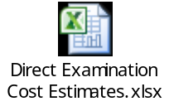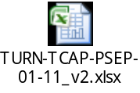

QUESTION TURN-TCAP-PSEP-02-12:

Please provide the total number of miles of pipeline for SoCalGas and SDG&E that are less than 1,000 feet long and will be subject to in-line inspections under the utilities’ alternative proposal (Amended Testimony, pp. 54-55

RESPONSE TURN-TCAP-PSEP-02-12:

The proposed alternative presented on pages 54-55 of the testimony describes the use of non-destructive examination (NDE) as a means of validating the integrity of pipeline segments that could potentially reduce cost and customer impact as compared to replacement for short pipeline segments. As stated in section IX.D of the testimony, approximately 1.7 miles (SoCalGas and SDG&E combined) have been identified as potential candidates for use of direct examination. If the Commission approves this proposed alternative, each project would be evaluated on a case-by-case basis during the engineering, design, and execution planning phase of the project for situations in which direct examination could be used in lieu of pressure testing or replacement in order to reduce overall cost and customer impacts.

QUESTION TURN-TCAP-PSEP-02-13:

The last paragraph in Section VIII of the utilities’ testimony (p. 58) discusses the Commission’s approval of three aspects of using the transverse field inspection tools (TFI). Please explain in detail the process that Sempra envisions for receiving the Commission approval, including but not limited to the following:
- Will the Sempra Utilities be supplying specific data and/or periodic reports to the Commission on the results of its use of the TFI tool on a regular basis? If so, please describe in detail the expected reports (in terms of expected content and timing).
- Do the Sempra Utilities envision some minimum number of a) inspections, b) miles, or c) other minimum amount of unit data and test results provided to the Commission before the Commission approves the TFI tools? If so, please describe in detail.
- Do the Sempra Utilities envision the need for approval from other government agencies (i.e., federal) in addition to the CPUC to substitute TFI tools for other more destructive and costly inspection tools? If so, please describe in detail.

RESPONSE TURN-TCAP-PSEP-02-13:

Our intention is to work collaboratively with CPSD to provide a study that will satisfy the need to validate TFI as an alternative equivalent approach to pressure testing. The specifics of this work have not yet been defined, but will be developed in detail pending approval of our proposal by the Commission. Additionally, see Response DRA-PZS-11-02(e), which is provided along with this response and which will be available on the SoCalGas website at the following link: http://socalgas.com/regulatory/R11-02-019.shtml.
SoCalGas and SDG&E do not anticipate that approval from other government agencies will be required. The PSEP was prepared at the direction of the CPUC in D.11-06-017 and the requirements of that decision are above and beyond existing Federal requirements. Should overlapping Federal requirements change in the future, SoCalGas and SDG&E will comply with those requirements, as necessary. See Response DRA-PZS-11-02(o), which is provided along with this response and which will be available on the SoCalGas website at the following link: http://socalgas.com/regulatory/R11-02-019.shtml.

