Program Name: | Chinese Language Efficiency Outreach (CLEO)
Program Number: | SoCalGas No. 3532
Quarter: | First Quarter 2008

- Program Description:

Chinese Language Efficiency Outreach (CLEO) - CLEO is a local, highly targeted residential, energy efficiency marketing, outreach, education and training Program that targets the hard-to-reach, Vietnamese, Indian, Chinese and Korean, (VICK) speaking residential customers of Southern California Edison (SCE) and Southern California Gas Company (SCG). This offering is an element of the SCE Education, Training and Outreach Program. The CLEO program will target joint SCE and SCG customers in demographic belts in Los Angeles, San Bernardino and Orange Counties with a high concentration of ethnic Asian customers.

CLEO is a ‘Non-Resource’ program with no energy saving goals. However the program, whenever possible, will provide a closure to the energy information by encouraging implementation of the energy efficiency measures.

HEES: The CLEO program added on a – Home Energy Efficiency Survey (HEES) component. HEES will target Vietnamese, Chinese and Korean customers as an in-language in-home, and phone home energy efficiency audit offering.

- Administrative Activities:

CLEO:
  - CLEO team and program managers from SCE and SCG met in person and over teleconference meetings every week to discuss and resolve specific program issues
  - CLEO is being consolidated based on customer feedback. For example around 20% of the remaining TV spots will be traded for Newspaper spots and the balance will be shifted to other activities with a greater impact.
  - CLEO’s highly successful seminar series in Chinese and Korean languages continue to exceed participation expectations. In line with our philosophy of ‘No Customer Left Behind’ CLEO will actively enroll customers calling the CLEO in-language toll free hotlines.

HEES:
- Global Energy Services (GES) and SCE started discussing implementation of the in-language Home Energy Efficiency Surveys (HEES). CLEO started mobilizing to expand the program so as to offer the in-language HEES services.
- GES received a Change Order for HEES implementation dated 12/31/2007
Effective from October 1, 2007.

- On January 16th, GES organized a comprehensive HEES training at Customer Technology Application Center (CTAC) provided by Marcos Quezada President of WaterWise Consulting and by John Arnett from KEMA.
- CLEO received HEES sign-up brochures in Chinese and Vietnamese languages.
  - A background check was conducted by ADP Services (Security Company) on all new home auditors.
- A Telephone system to handle calls in all languages was commissioned.

- Marketing Activities:

CLEO:
- CLEO partnered with the South Coast Chinese Cultural Center in Irvine to offer the CLEO program to its members.
- GES continued its community outreach effort in Chinese, Vietnamese and Korean communities. CLEO actively participated in the Chinese New Year celebrations in Monterey Park and the TET festival which is the premier Vietnamese New Year Celebration in Orange County.
- Over 1000 customers visited the CLEO Booths and eagerly participated in CLEO offerings. The Chinese New Year booth resulted in 200, 5-minute HEES and over 150 customers signed up for in-home surveys.
- CLEO contacted the winners of the drawing contests selected by SCE. The winning entries will receive prizes from Ms. Polly Low, Council member at the City of Rosemead at the upcoming summer seminar series on April 5, 2008. Winners will also be featured in local Newspapers.
- The program continued its marketing and outreach to over a hundred Korean churches and Adult day care centers. CLEO brochures and handouts were mailed to these churches. This has resulted in a considerable interest and resulted in requests for CLEO Korean seminars at these churches.
- The new CLEO program web-site www.cleosave.com was uploaded. This in-language web-site has been upgraded to be an effective marketing tool.

HEES:
- SCE mailed out over 10,000 targeted in-home enrollment cards to select Chinese and Vietnamese demographics.
- Toll free hot-lines were provided by GES with trained Chinese, Vietnamese and Korean staff answering customer request for audits.
- CLEO also drew upon the Chinese and Vietnamese seminar attendees in 2007 offering them the opportunity to participate in the HEES program.
- Over 300 customers were signed-up for the in-home audit from the database of 2007 program attendees.
- CLEO received over 170 requests for surveys at the Chinese New Year Booths.

- Direct Implementation Activities:

CLEO:
  - On January 28th, CLEO offered a seminar at the South Coast Chinese Cultural Center (www.sccca.us) the premier Chinese cultural center of Irvine. Over 40 customers signed up but the seminar was attended by only 20 customers. These customers also signed up for in-home HEES
  - On February 8th. thru February 10th. CLEO participated in the 3-day Vietnamese New Year TET celebrations. CLEO staff eagerly explained the program offerings and helped customers with information on SCE and SCG’s EE programs. Customers also filled up the short HEES surveys.
  - On February 9th. &10th. CLEO participated in the Chinese New Year celebrations hosted by the City of Monterey Park. The CLEO booth was an astounding success with customers lining up 50 deep to fill up the 5-minute HEES surveys. Over 200 short surveys were completed at the Booth. An additional 150 signed up for the in-home surveys.
  - The short version of HEES were collected at each of the seminars and community Booths, over 100 new HEES Surveys were submitted to SCE/KEMA for evaluation.
  - On March 15th. CLEO offered a seminar at the Calvary Mission Church in Buena Park. Over 50 customers attended the seminar. This is a continuation of CLEO’s strategy of ‘Faith Based Outreach’ to the Korean community

HEES:
  - CLEO HEES auditors received in-home, classroom and field training with KEMA’s field auditors.
  - CLEO brochures for the HEES surveys were finalized.
  - CLEO started to sign up customers for HEES at the Chinese and Korean seminars offered in December.
  - In January, CLEO completed 227 In-home and 20 Phone surveys. HEES implementation details are provided below. CLEO auditors installed 754 CFL’s, 166 faucet aerators and 13 showerheads at the 227 homes.
  - In February, CLEO completed 211 In-home surveys. HEES implementation details are provided below. CLEO auditors installed 688 CFL’s, and 59 showerheads at the 211 homes.
  - In March, CLEO completed 352 In-home surveys. HEES implementation details are provided below. CLEO auditors installed 1243 CFL’s (13W - 416; 23W - 575; 23W – 252), 23 showerheads, 127 faucet aerators at the 352 homes.
  - In March CLEO has completed 100% of the budgeted in-home surveys.

- Program Performance/Program Status:

☑ Program is on target
⁬ Program is exceeding expectations
⁬ Program is falling short of expectations

CLEO has aggressively launched the marketing and implementation of the program. CLEO is on track to meet and exceed the overall program goals. CLEO has enrolled over 450 Chinese and Vietnamese customers while presenting 2 seminars. Cumulatively CLEO has completed over 70% of its overall goals.

- Program Achievements (non-resource programs only):
CLEO:
  - Year to date (YTD) CLEO has completed and received approval from SCG for 2123 HEES surveys - 106% of program goal, participated in 13 community events Booth – 87% of program Goal, offered 54 seminars with a overall attendance of more than 2500 customers – 72% of program goals and offered over 420 spots on radio, newspaper and television – 58% of media goals. The program continues to build significant community relations and brand recognition.

HEES:
  - In Q-1, CLEO launched HEES as an extension of its program offerings. The program aggressively geared up for the HEES program and added new staff. In Q-1, CLEO-HEES conducted 790 In-home surveys and 20 Phone surveys. The program also directly installed over 2000 CFL’s, 95 showerheads and over 300 faucet aerators.

- Changes in program emphasis, if any, from previous quarter (new program elements, less or more emphasis on a particular delivery strategy, program elements discontinued, measure discontinued, budget changes, etc.)

  - None reported

- Discussion of near-term plans for program over the coming months (e.g., marketing and outreach efforts that are expected to significantly increase program participation, etc.)
CLEO:
  - CLEO has partnered with the City of Rosemead and will offer a series of seminars at the Rosemead City Hall. The winners of the ‘Energy Artist Contest’ will also be announced and prizes awarded by the Mayor of Monterey Park. CLEO will continue to partner with local cities and offer free energy saving seminars.

HEES:
  - CLEO plans to offer in-home, in-language HEES surveys to the Chinese, Vietnamese and Korean communities. CLEO will streamline the reporting mechanisms and build on the HEES experience to carve a sustainable HEES program in the ethnic Chinese, Vietnamese and Korean communities.

- Changes to staffing and staff responsibilities, if any

  - None reported

- Changes to contracts, if any
  - None reported

- Changes to contractors and contractor responsibilities, if any
  - None reported

- Number of customer complaints received
  - None reported

- Revisions to program theory and logic model, if any
  - None reported

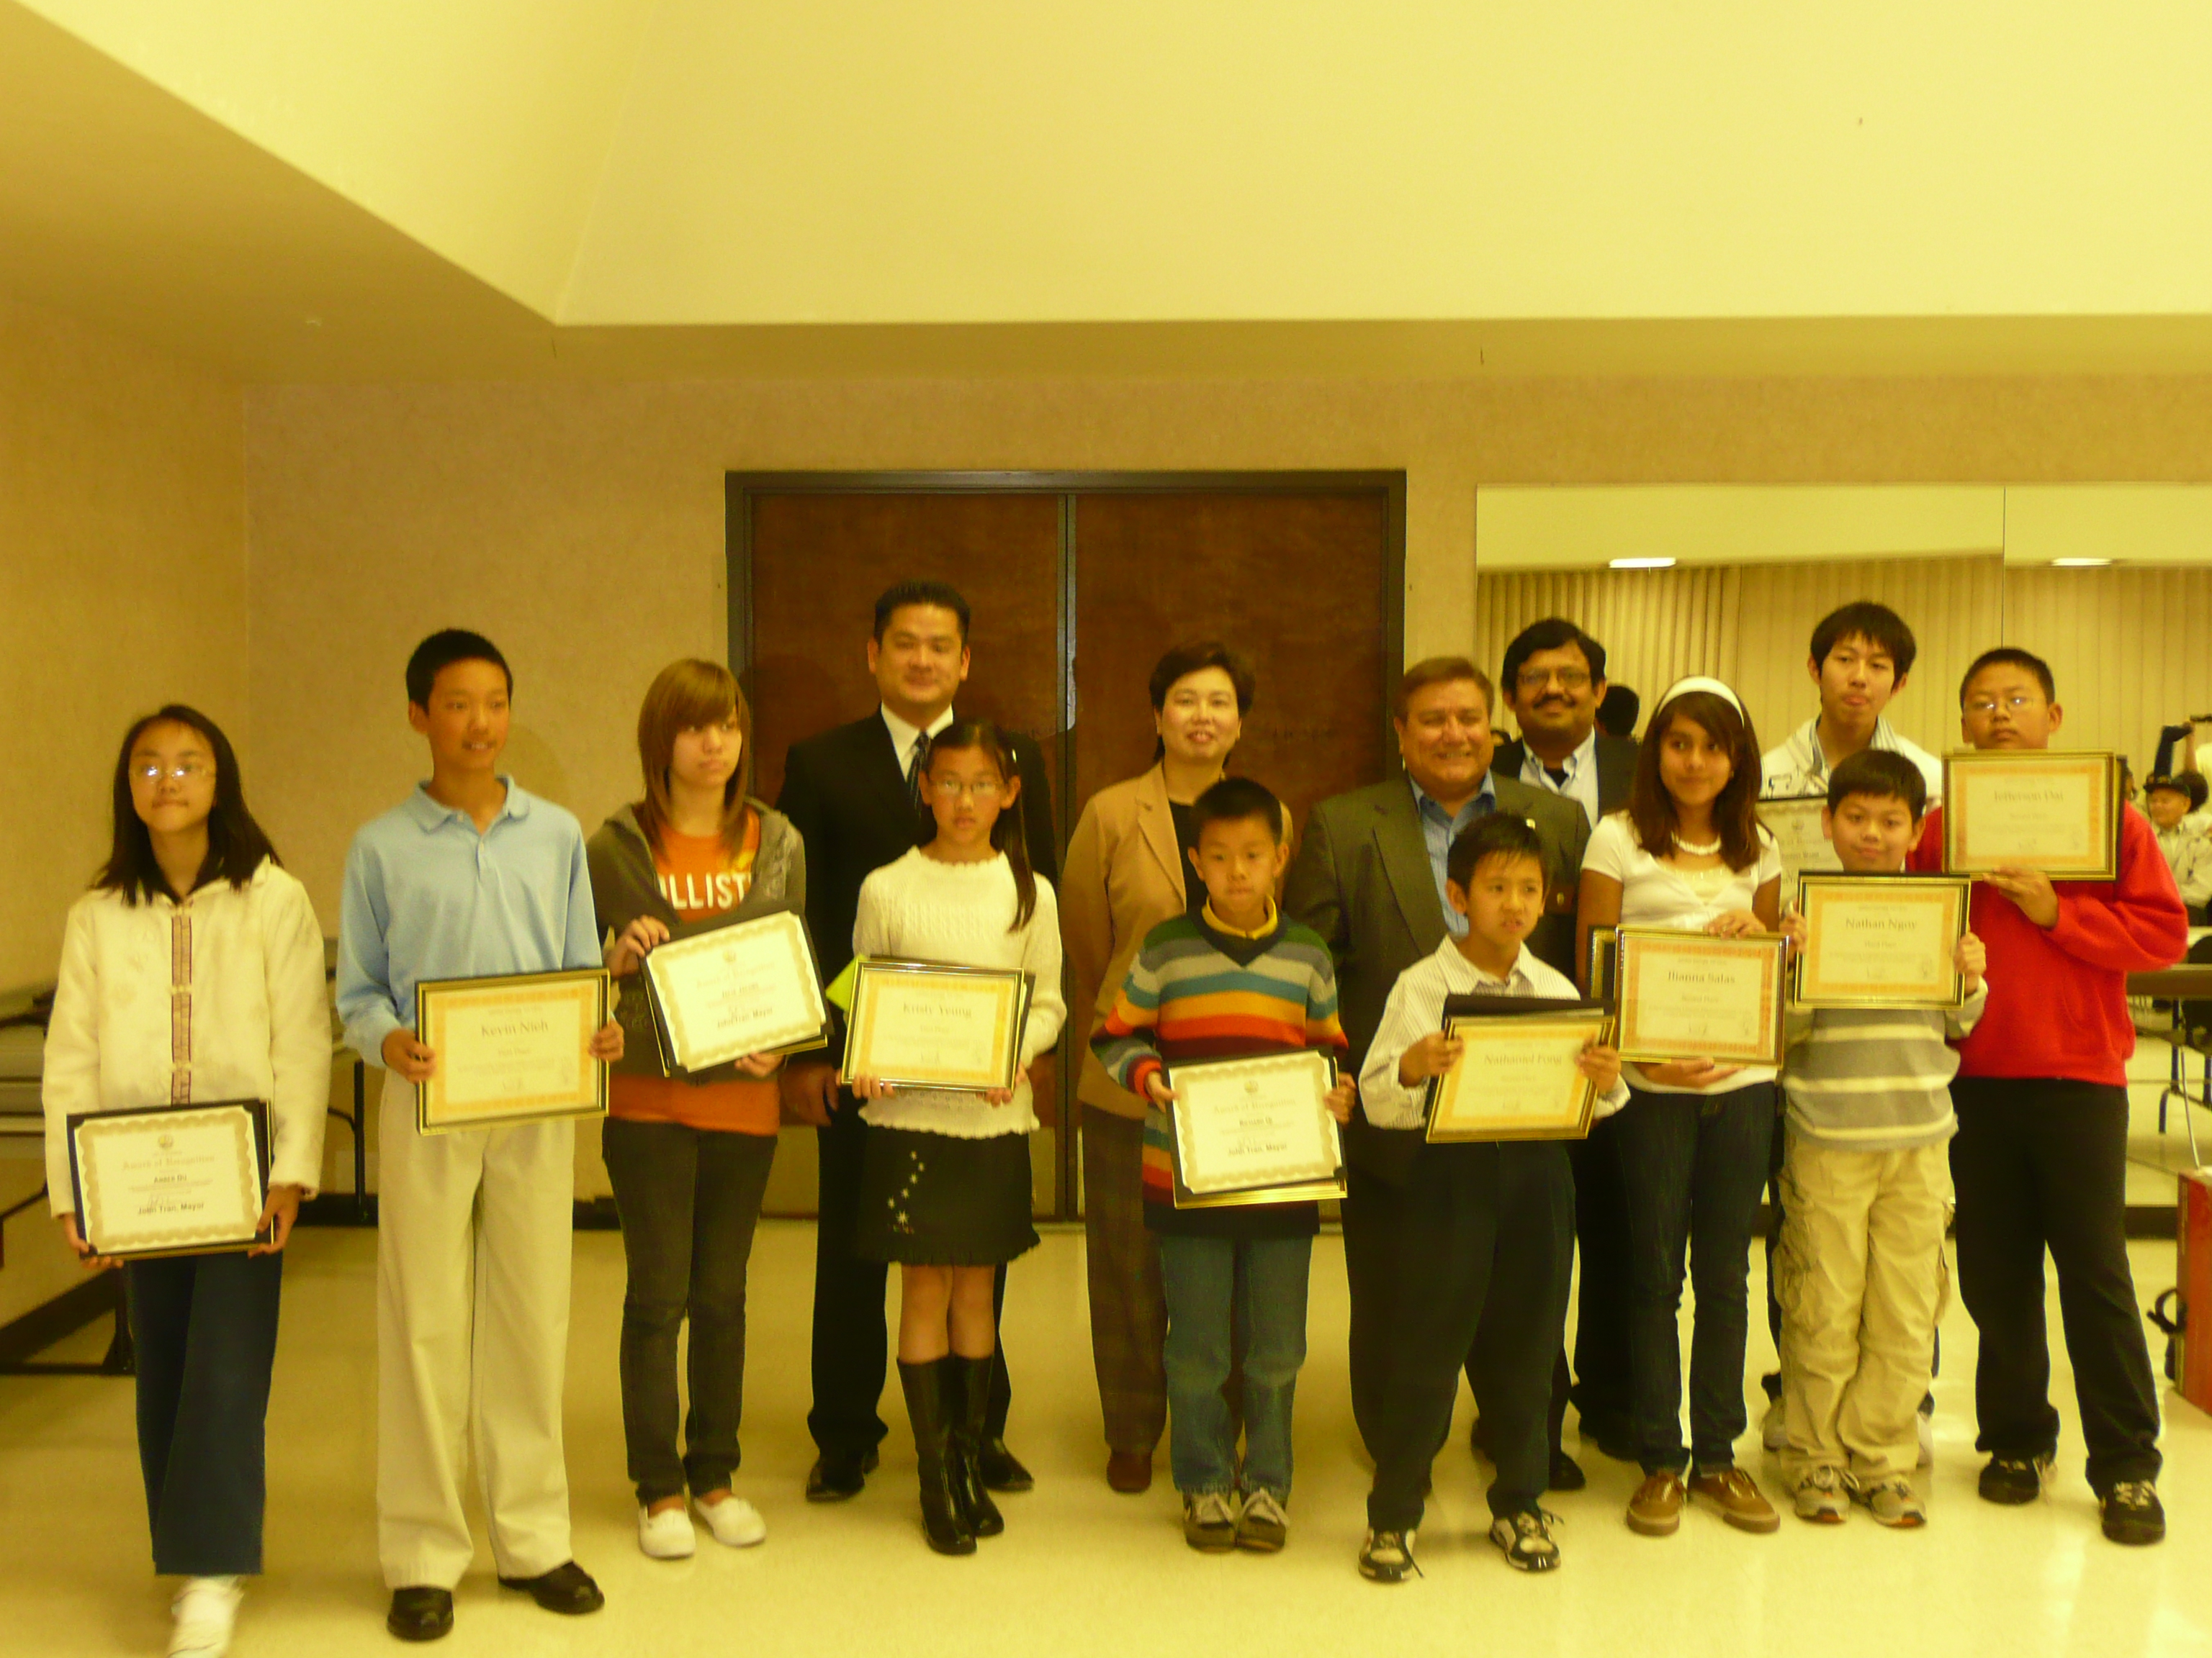

From Left Mayor John Tran, Council Women Ms. Polly Low and Mayor Pro-tem Mr. John Nunez and Basu Mukherjee (CLEO Program) with the winners of the ‘Energy Artist Contest’. Please visit www.cleosave.com

